

**Office of Institutional Research and Planning**

**Leavers Survey Analysis**

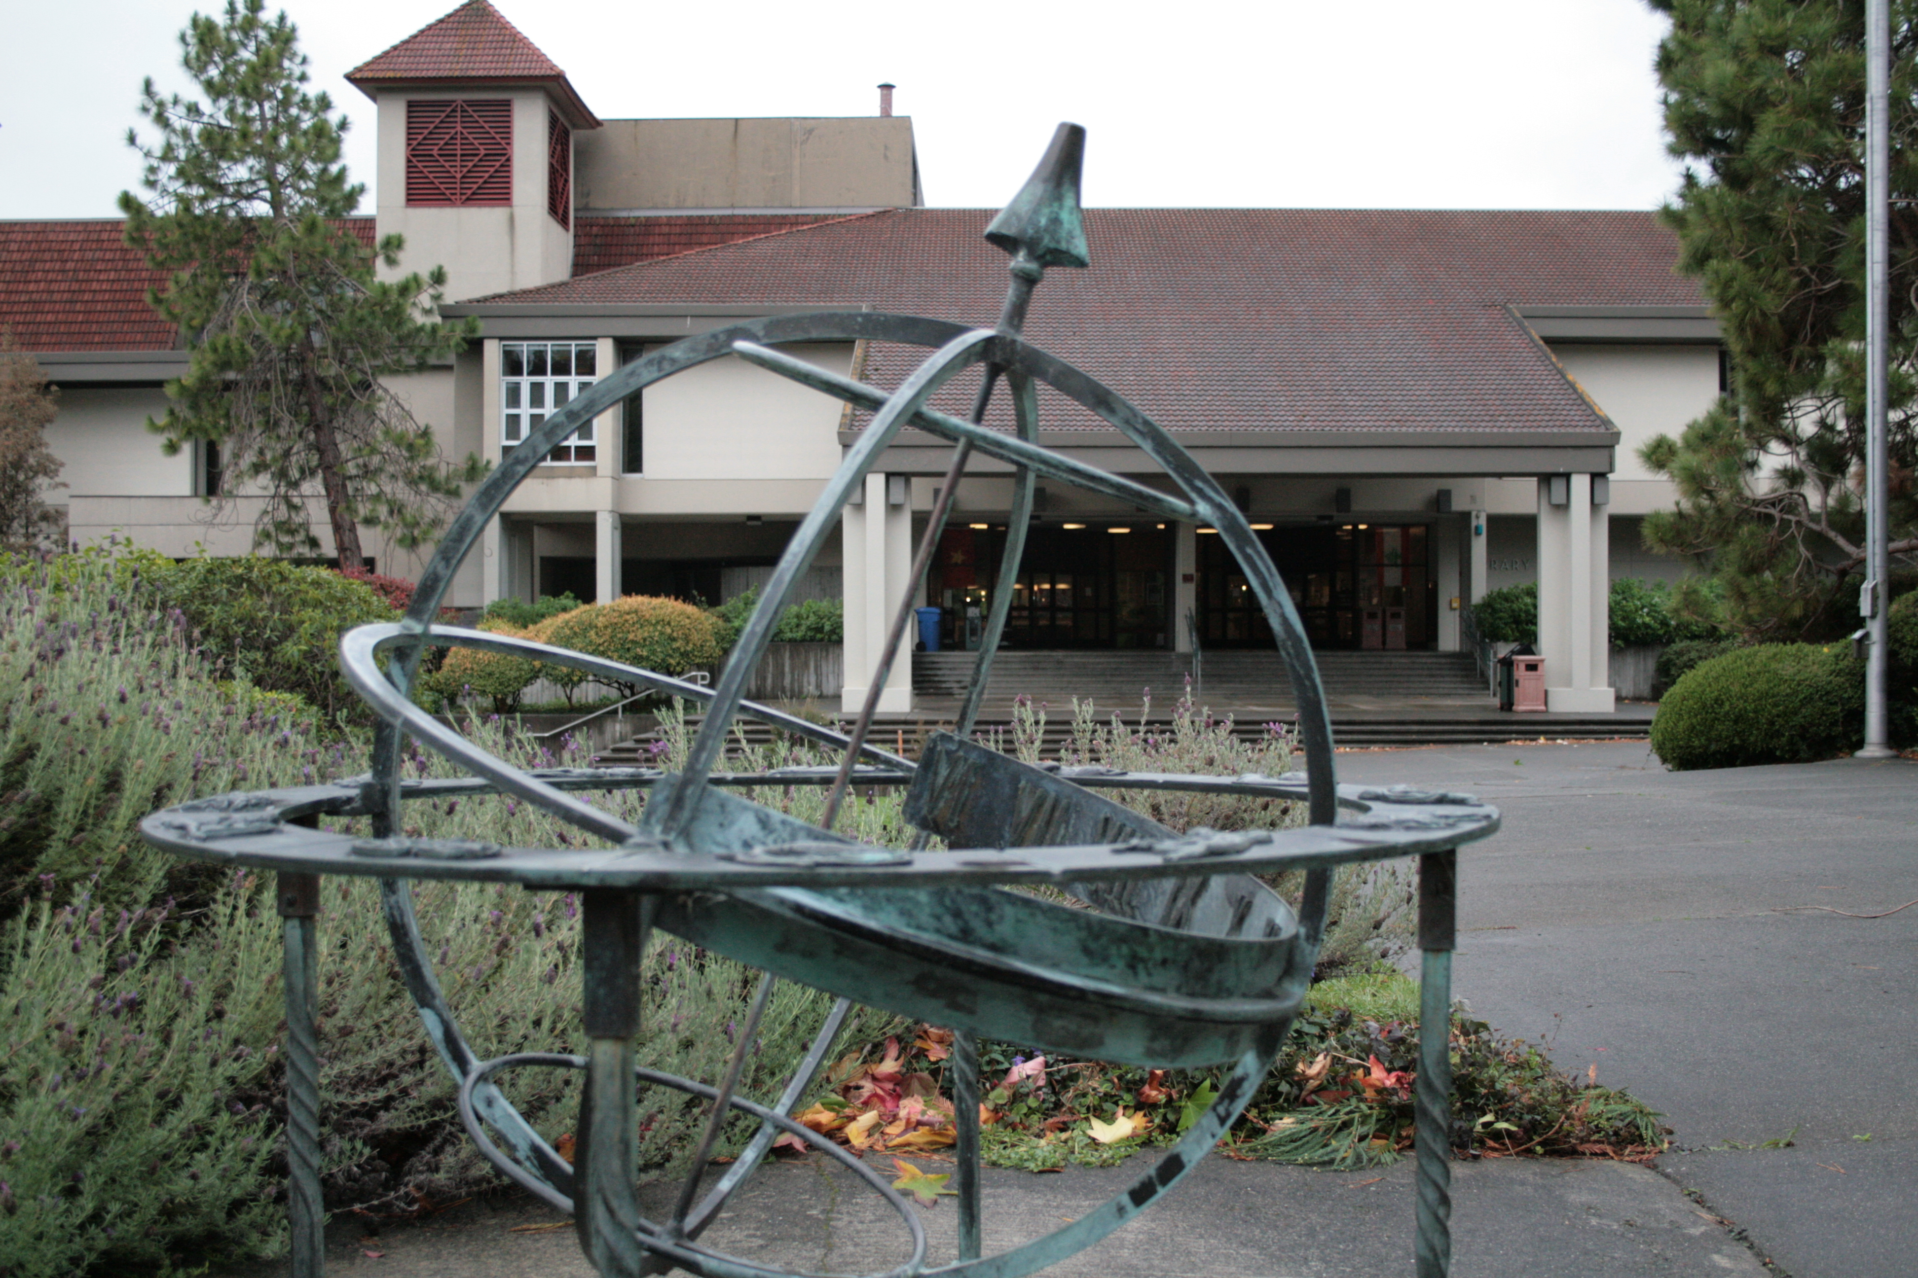

*Photo Credit: John Filce*

**Office of Institutional Research and Planning**

One Harpst Street • Arcata, California 95521-8299 • 707.826.5489 • [www.humboldt.edu/irp](http://www.humboldt.edu/irp)

# Introduction

Since Fall of 2010, Humboldt State University has conducted a survey of continuing eligible undergraduate students who were enrolled in the spring semester, but were not enrolled by the second day of the fall semester (referred to as leavers). Students who left for reasons known to the University such as academic disqualification and leave of absence were omitted from sampling. At the end of Spring 2012, 246 students were academically disqualified, 54% of whom had freshman standing.

# Method

## Participants

An email invitation was sent to the 431 students identified as leavers. Of those 22% of students responded. Upper Division (Junior and Senior standing) students were overrepresented in the responses (81%) when compared to the registered population of undergraduate students (72%). First generation (53%) and probationary (19%) students were more prevalent in the leaver’s population while low income was lower (38%).

*Characteristics of Leavers and Responders*

|  |  |  |  |  |  |  |
| --- | --- | --- | --- | --- | --- | --- |
| **SPRING 2012 UNDERGRADUATES ELIGIBLE FOR FALL 2012 AFTER SECOND DAY OF CLASSES** | | | | | | |
|  | Registered | | Not Registered | | | |
| Sent Survey | | Responded | |
| Total (n) | 5,140 | | 431 | | 95 | |
| **Gender** |  |  |  |  |  |  |
| Female | 2,700 | 53% | 202 | 47% | 49 | 52% |
| Male | 2,440 | 48% | 229 | 53% | 46 | 48% |
| **URM** |  |  |  |  |  |  |
| Yes | 1,458 | 28% | 135 | 31% | 29 | 31% |
| No | 3,384 | 66% | 245 | 57% | 56 | 59% |
| Unknown | 298 | 6% | 51 | 12% | 10 | 10% |
| **Level** |  |  |  |  |  |  |
| Lower Division | 1,443 | 28% | 136 | 32% | 18 | 19% |
| Upper Division | 3,697 | 72% | 295 | 68% | 77 | 81% |
| **Low Income** |  |  |  |  |  |  |
| Yes | 1,944 | 38% | 92 | 21% | 19 | 20% |
| No | 1,710 | 33% | 71 | 17% | 14 | 15% |
| Unknown | 1,486 | 29% | 268 | 62% | 62 | 65% |
| **First Generation** |  |  |  |  |  |  |
| Yes | 2,299 | 45% | 228 | 53% | 53 | 56% |
| No | 2,609 | 51% | 187 | 43% | 38 | 40% |
| Unknown | 232 | 4% | 16 | 4% | 4 | 4% |
| **Probationary Status** |  |  |  |  |  |  |
| Good | 4,812 | 94% | 338 | 79% | 84 | 88% |
| Probation | 293 | 6% | 83 | 19% | 9 | 9% |

# Leavers and Delayed Returners

## Delayed Registration

Fourteen percent of responders said they would be registering for the fall semester. Finances (85%) was the most cited reason by students for delayed enrollment followed by a hold on their account (62%), needing permission numbers (46%), and needing to meet with their advisor (38%).

## 

## Leavers

Eighty-six percent of responder said they would not be coming back to Humboldt State University in the fall semester. Of these students, 48% said they would be back at some point and an additional 8% said they just needed to complete some last requirements to graduate. The remaining 44% were leavers who indicated they would not be returning to HSU.

# Common Factors for students leaving

Based on previous results, students have typically said that financial and academic issues play a major role in leaving. This year, many leavers said they did not have the money, they did not like the geographic location of HSU, and they had family reasons for leaving.

*Top Issues for leaving HSU*

|  |  |
| --- | --- |
| **Answer Options** | **Very/Somewhat Important** |
| Financial issues | 54% |
| Geographic location of HSU | 53% |
| Family Reasons | 42% |
| Homesickness | 21% |
| Drugs and/or Alcohol | 21% |
| Personal Health Issues | 15% |

## Financial Aid Award Status

About 39% said they never applied for aid and about 33% applied by were denied aid. Only about 17% of students who said they had issues were awarded finical aid money.

## Other Financial Issues

Other top issues that affected students was that their family could not contribute enough toward the cost of their education, their personal financial situation changed for the worse (e.g., unexpected expenses or loss of job), or they were unable to get a job while attending HSU.

*Top Reasons for having finical Issues*

|  |  |
| --- | --- |
| **Answer Options** | **Very/Somewhat Important** |
| My family could not contribute enough | 72% |
| Financial situation changed for the worse | 61% |
| I was unable to get a job | 50% |
| I did not receive enough financial aid | 44% |
| I lost my financial aid | 39% |
| I had trouble maintaining a budget | 29% |

## Academics

Most students were satisfied with HSU academics; however 31% said they were disappointed with the quality of instruction and 22% said the courses were not challenging enough. Interestingly, only 17% said they were displeased with their own academic performance and 8% said the courses were too difficult. This might suggest that some students are lost because courses are not rigorous enough for students.

*Top Academic Issues*

|  |  |
| --- | --- |
| **Answer Options** | **Very/Somewhat Important** |
| Disappointed with the quality of instruction | 31% |
| The major I want is not offered by HSU | 25% |
| Courses were not challenging enough | 22% |
| Displeased with own academic performance | 17% |
| Courses were too difficult | 8% |

## Course Selection

Most students (69%) said they had difficulty getting the courses they needed for their degree. Interestingly, all the students who said they had trouble getting courses said they would not return to HSU to finish their degree.

## Campus Community Culture

Most students who left were satisfied with the campus and community culture as well as the quality of student life. About 1 in 4 students said they felt alone of isolated. Racial or ethnic tension overall was low, but 1 student reported feeling tension on campus.

*Top Campus Culture Issues*

|  |  |
| --- | --- |
| **Answer Options** | **Strongly Agree/Agree** |
| I was satisfied with the campus community | 76% |
| I was satisfied with the quality of student life | 70% |
| I felt alone or isolated | 24% |
| Dissatisfied with my on-campus roommate(s) | 15% |
| I felt racial or ethnic tension on campus | 3% |

*Top Community Culture Issues*

|  |  |
| --- | --- |
| **Answer Options** | **Very/Somewhat Important** |
| I was satisfied with the quality of student life | 67% |
| I was satisfied with the off-campus community | 67% |
| I felt alone or isolated | 27% |
| There was a lack of off-campus housing for me | 9% |
| I felt racial or ethnic tension off campus | 9% |

## Geographic Location

Over half (55%) of the students who left said Humboldt State and the community was isolated; however, only 24% said they were too used to a larger city.

*Top Geographic Location Issues*

|  |  |
| --- | --- |
| **Answer Options** | **Strongly Agree/Agree** |
| The campus is isolated | 55% |
| The community is isolated | 52% |
| I wanted to be closer to friends or family/relatives | 39% |
| There is not enough to do in Humboldt | 36% |
| My family/relatives needed/ wanted me to be closer | 33% |
| I'm too used to living in a larger city | 24% |

## Enrollment in another institution

When asked if they had enrolled in another institution twenty-two of the leavers (68%) indicated that they had. Over half (55%) of those students said they were going to community college. Of the students enrolling in community college 83% of those also indicated that financial issues were very or somewhat important to their decision not to return to HSU for the Fall 2012 semester. A majority (54.5%) of these students also indicated the geographic location of HSU was somewhat important in their decision to leave and 25% were just completing graduation requirements.

## Enrollment in Community College

From qualitative responses in 2012, seniors leaving identified that they just needed to completed a lower division course and then would graduate. Freshman and sophomore students all reported that financial reasons were most important. There were no juniors who said they were going to community college.

# Longitudinal Trends

This survey has been administered to all undergraduates who were not registered by the second day of classes each semester since Fall 2010. Below are the longitudinal trends for those students who attended in Spring but did not return the following Fall. The 2010 survey identified that academic issues, financial issues and geographic location were the most important issues for students not returning. The 2011 survey again identified academics and financial issues as the main reasons students were not returning. In 2012 financial issues were still important but academics were not as important.

*Survey Response Rate and Percentage of Leavers*

|  |  |  |  |
| --- | --- | --- | --- |
| **Answer Options** | ***2010*** | ***2011*** | ***2012*** |
| Response Rate | 26% | 21% | 22% |
| Not planning to register | 92% | 81% | 86% |

*Most Important Issues for Leaving*

|  |  |  |  |
| --- | --- | --- | --- |
| **Answer Options** | ***2010*** | ***2011*** | ***2012*** |
| Financial issues | 58% | 48% | 54% |
| Geographic location of HSU | 25% | 24% | 53% |
| Family Reasons | 33% | 17% | 42% |
| Homesickness | 20% | 32% | 21% |
| Drugs and/or Alcohol | 14% | 24% | 21% |
| Personal Health Issues | 27% | 46% | 15% |

## Financial Issues

Financial issues were identified as a leading factor for students so a sub topic was added in 2011 and refined in the 2012 survey to get more information about the issue. Most students who had issues paying for college were not getting enough from their families, had unexpected financial situations strike, and/or couldn’t find work.

*2011 & 2012 Refined Financial Issues for Leaving*

|  |  |  |  |
| --- | --- | --- | --- |
| **Answer Options** | ***2010*** | ***2011*** | ***2012*** |
| My family could not contribute enough |  | 91% | 72% |
| financial situation changed for the worse |  | 90% | 61% |
| I was unable to get a job |  | 80% | 50% |
| I did not receive enough financial aid |  |  | 44% |
| I lost my financial aid |  |  | 39% |
| I had trouble maintaining a budget |  | 51% | 29% |

## Academic Issues

*Most Important Academic Issues for Leaving*

|  |  |  |  |
| --- | --- | --- | --- |
| **Answer Options** | *2010* | *2011* | *2012* |
| Disappointed with the quality of instruction |  | 50% | 31% |
| The major I want is not offered by HSU |  |  | 25% |
| Courses were not challenging enough |  | 60% | 22% |
| Displeased with own academic performance | 34% | 50% | 17% |
| Courses were too difficult |  | 67% | 8% |
| Disappointed with the quality of instruction |  |  | 31% |

## Geographic Location

*Most Important Geographic Location Issues for Leaving*

|  |  |  |  |
| --- | --- | --- | --- |
| **Answer Options** | *2010* | *2011* | *2012* |
| The campus is isolated |  | 60% | 55% |
| The community is isolated |  | 60% | 52% |
| I wanted to be closer to friends or family/relatives |  | 77% | 39% |
| There is not enough to do in Humboldt |  | 75% | 36% |
| My family/relatives needed/ wanted me to be closer |  | 58% | 33% |
| I'm too used to living in a larger city |  | 58% | 24% |

## Enrollment in another institution

2011 & 2012 Refined Enrollment in Another Institution

|  |  |  |  |
| --- | --- | --- | --- |
| **Answer Options** | *2010* | *2011* | *2012* |
| Enrollment in another institution | 53% | 44% | 68% |
| Community College |  | 52% | 55% |
| Other California State University campus |  | 14% | 14% |
| Other Public 4-year institution |  | 19% | 27% |
| Other Private 4-year institution |  | 10% | 5% |

## Enrollment in Community College

In 2011 and 2012 students who went to a community college were isolated for analysis. In 2011, none of the students going to community college had financial aid and in 2012 only 30% of students did. Over 90% of these students (both years) reported being from 250 miles or further away from HSU.