BLOCK SCHEDULING AND ENROLLMENT
A proposal to the Enrollment Management Working Group

Block scheduling is defined in multiple ways, and implementation models are diverse. In general, block scheduling and enrollment have been used as a means to enroll students in courses needed for timely progress toward the degree and as a framework for learning communities among students with similar majors. There is some indication that students appreciate knowing that some scheduling has been done on their behalf. Our proposal will focus upon ways to enhance student success, with increased graduation and retention rates and decreased time to degree as the desired outcomes.

This document serves as a proposal to implement a pattern of Block Scheduling and Enrollments during the registration process at Humboldt State University. It is the product of discussions among the HSU Associate Deans (Ayala, Hackett, Paynton and Zechman), Registrar Clint Rebick, Office of the Registrar staff, and Vice Provost Jená Burgess. We hope this proposal may serve as a framework for moving forward with an HSU model for Block scheduling and enrollment.

Common terminology:
- Block Scheduling- providing clusters of courses available for student enrollment
- Block Enrollment- pre- enrollment of students in designated clusters of courses

Guiding Principles:
- Proposed models should facilitate timely completion of a degree and support student goals.
- Block Scheduling in specific courses balanced to provide sufficient flexibility for pre-determined student exploration.
- Promote, where possible, learning communities of students with similar majors (e.g. specific STAT, CHEM, etc. sections for specific majors)
- Students will be block enrolled in specific sections in a pre-determined proportion of their course load
- Students will have some flexibility to swap sections of pre-enrolled courses if space is available, but will not be able to change the assigned course without permission.
- Avoid block enrollment of courses that would lead to future course/GE redundancies- particularly problematic with undeclared students.

Overview (See Figures 1 and 2 for block patterns of undeclared and declared students, respectively.)

Year 1: 2013/2014
Block scheduling for English will be implemented for all first time freshmen beginning Fall 13. All freshman students will engage in a self-assessment and placement for enrollment in either a full year of ENGL 102/103 sequence (Stretch English) or ENGL 104 in either Fall or Spring semester. Those selecting the single English course, ENGL 104, will be enroll based on availability - half enrolling in Fall, the other half in Spring.

In addition, declared students will be block enrolled in additional Lower Division Area A GE (COMM 100 and a critical thinking course), also split among incoming freshmen and alternating between semesters.

Those students assigned to remedial Math will be block enrolled in the appropriate remediation section in their first Fall semester. Continued remediation in Spring will depend on the sequence of remediation courses and/or successful completion. This process will require close coordination between the Registrar and the Math Department over specific dates during summer to determine Math eligibility and course demand across possible Math courses.

Further block scheduling patterns depend on declaration of a major, and evaluation for Math eligibility.

Year 2: 2014/2015
Year 2 implementation allows for students with declared majors to be block enrolled in an appropriate Math class (MATH 115 or MATH 105 for science majors, STAT 108 for selected Professional Studies Programs, etc.), and one or two additional major-specific lower division gateway courses per semester (Figure 2). Academic departments will select major-specific courses for block enrollment. The following are examples of major-specific blocks:

Biology major: No remediation
Fall: MATH 105/115, BOT 105
Spring: ZOOL 110, CHEM 109

Biology major: With remediation (and assuming Fall completion)
Fall: BOT 105
Spring: CHEM 109, ZOOL 110

Wildlife major:
Fall: WLDF 210, CHEM 107
Spring: ZOOL 110, BOT 105

Fisheries major:
Fall: FISH 260, CHEM 107
Spring: OCN 109, BIOL 105 (or FISH 220)

Figure 1
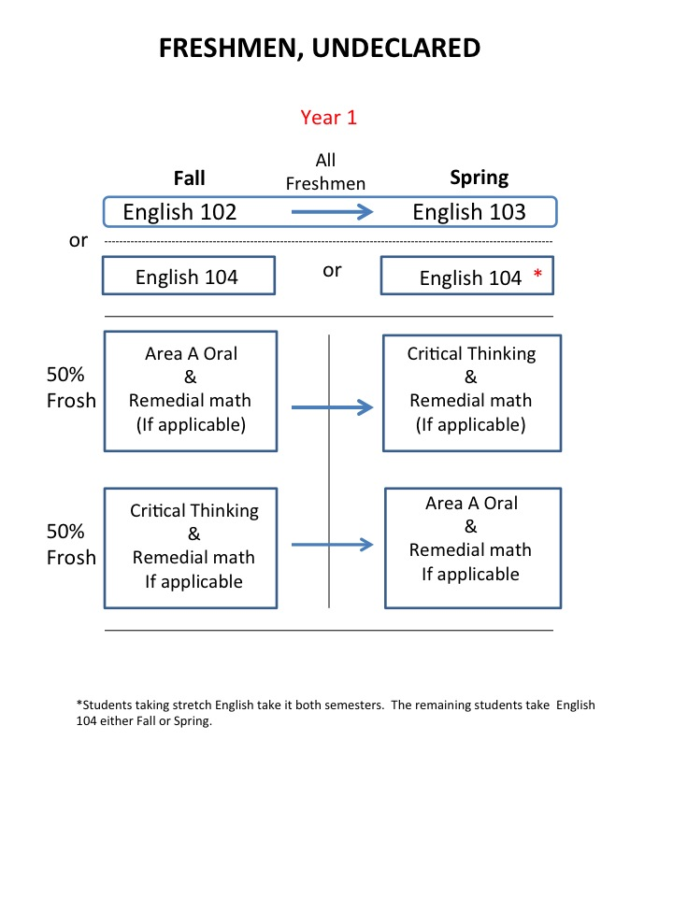

Figure 2
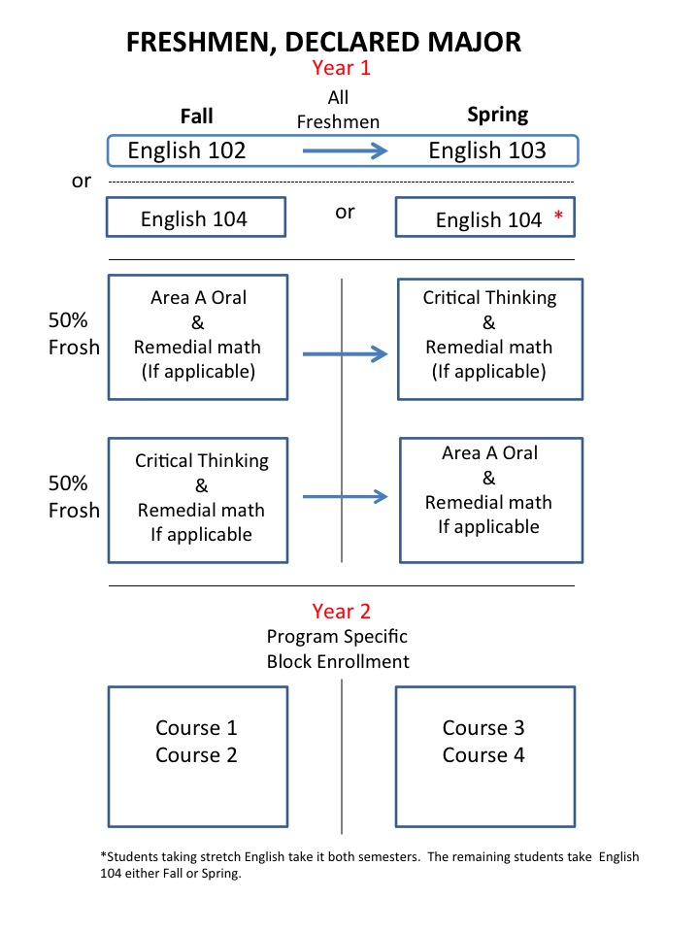

Issues to be addressed:
- Should students be able to drop a class they are enrolled in? By what process and following what protocol?
- Are critical thinking (LD GE Area A) courses appropriate for first semester freshmen?
- Implementation for Fall 2013 would require revision of numerous HOP advising materials in a short time frame.
- Stretch section of ENGL 102/103 courses will anchor semester 2 and may create conflicts.
- How will Spring semester block enrollment interface with priority registration?
- Possible implementation of a 3 unit freshman seminar would change proposed enrollment pattern.

